

DEPARTMENT OF COMPUTER SCIENCE – UBIT

“Assembly language”

CSSE – 403

Muhammad Suleman

Section ‘A’ (EVENING)

EB23210106101

Submitted to: SIR FAROOQ

ASSIGNMENT-06

**LAB TASK # 06**

**Q# 01**: Write a program that takes a single character input and displays it in a new line

**INPUT:**

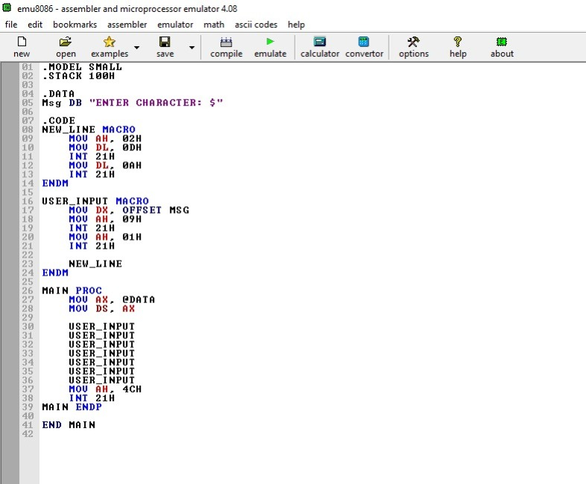

**OUTPUT:**

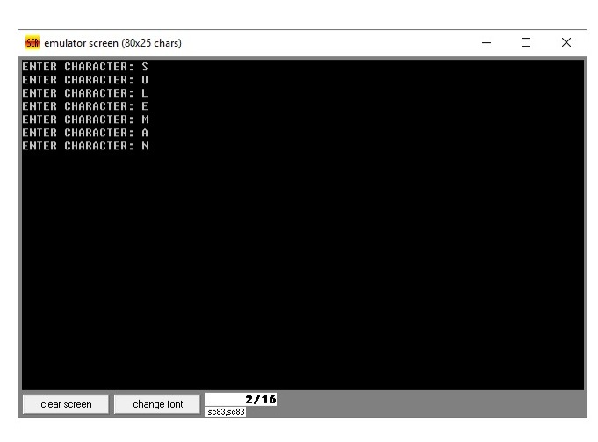

**This program reads a single character input and displays it on a new line using basic I/O interrupts in assembly language.**

**Q# 02**: Write a program to make your semester mark sheet using carriage return and line feed macro

**INPUT:**

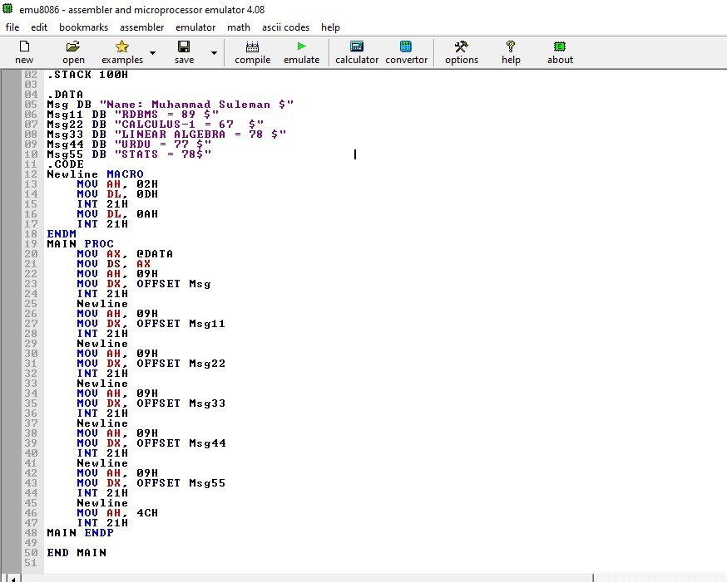

**Output:**

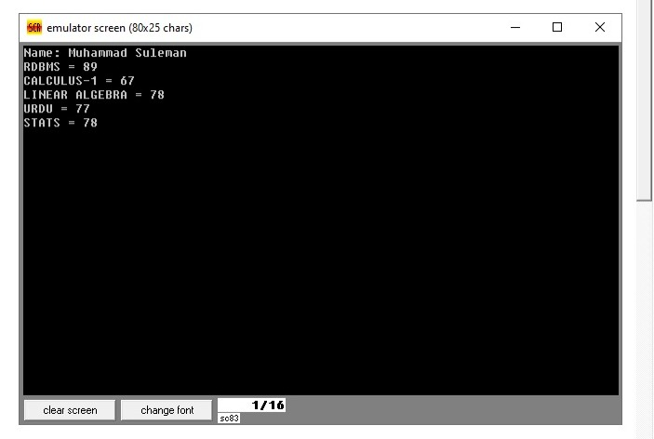

**This program creates a formatted semester mark sheet by using a macro to move to new lines, making the output clean and easy to read.**